Movie Landing Page Website Design

Name : Adapala naga sivaji

Mail Id : sivajiadapala13@gmail.com

Phn No : 6281717151

Roll N0 : 20HU1A0414

College Name : Chebrolu engineering college

**Source Code:**

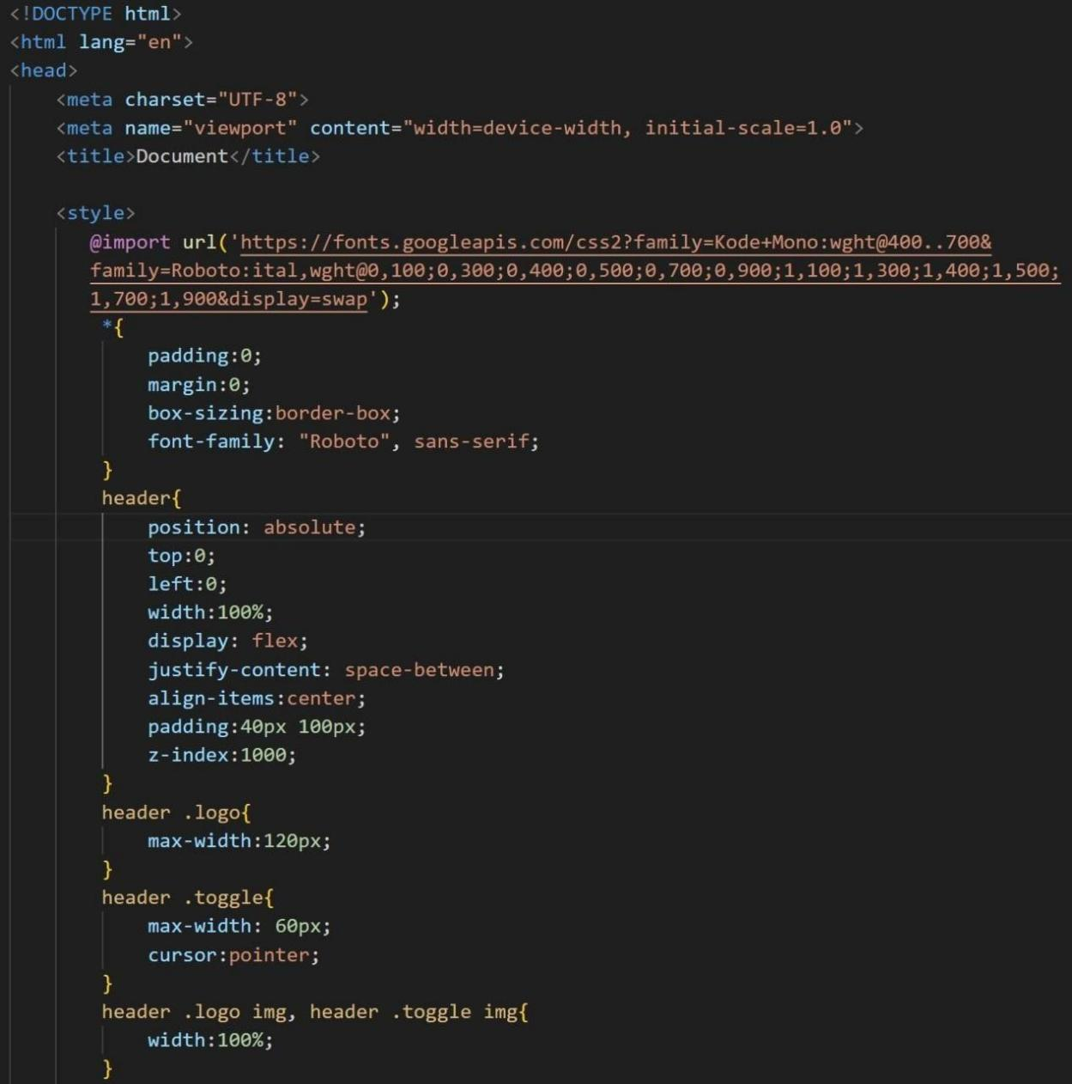

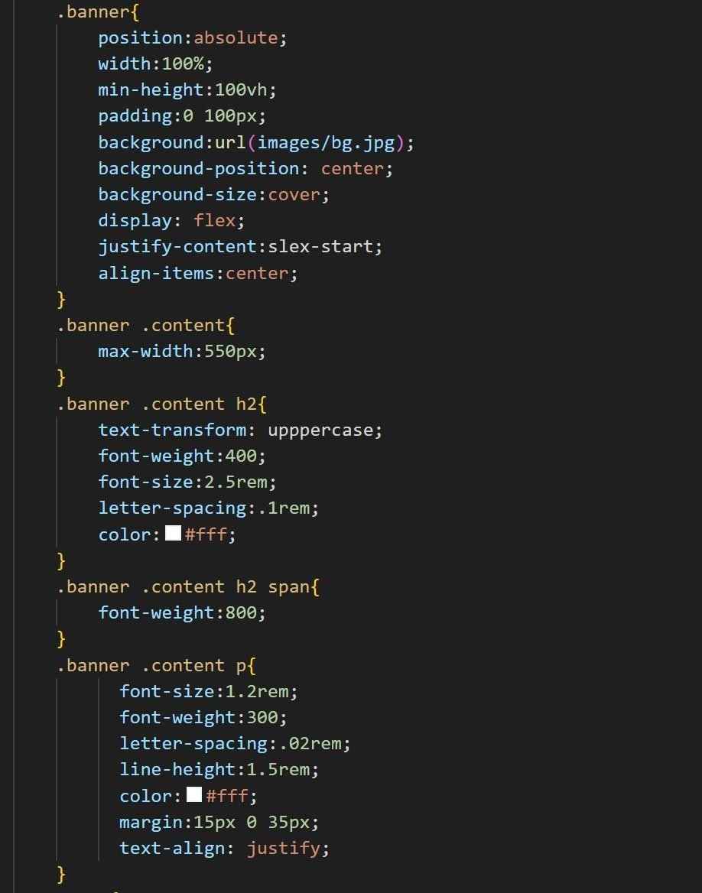

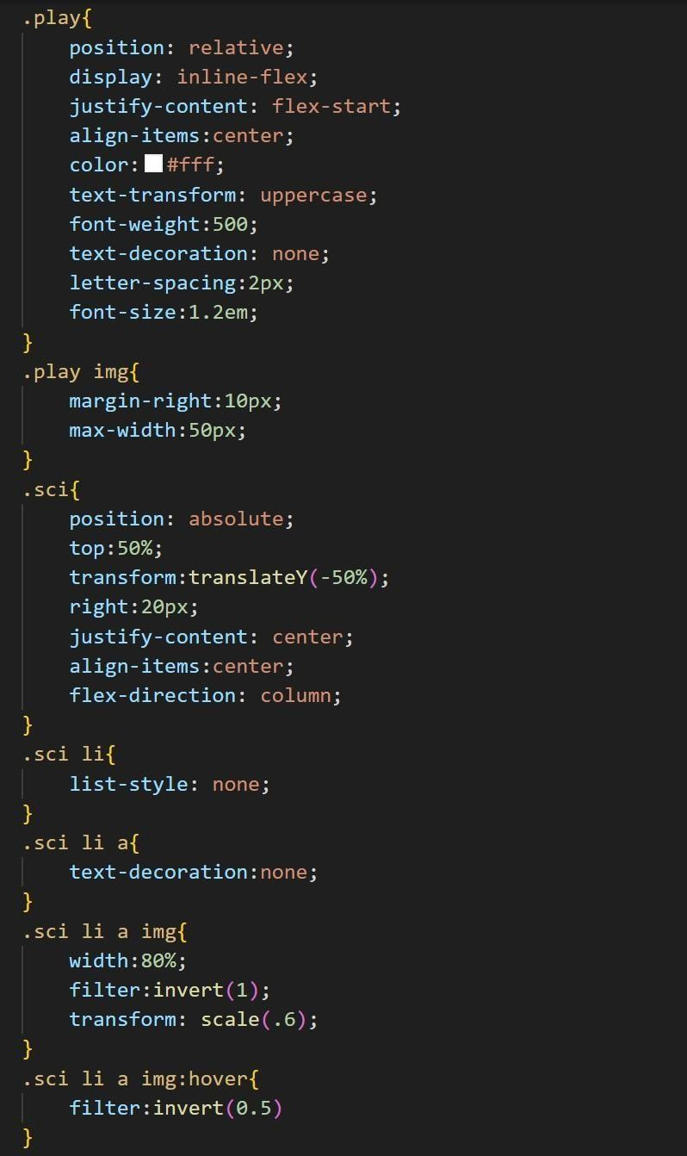

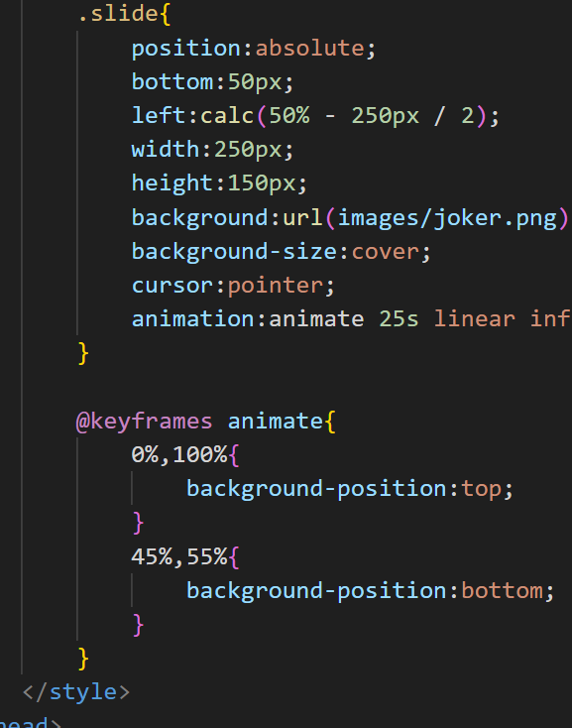

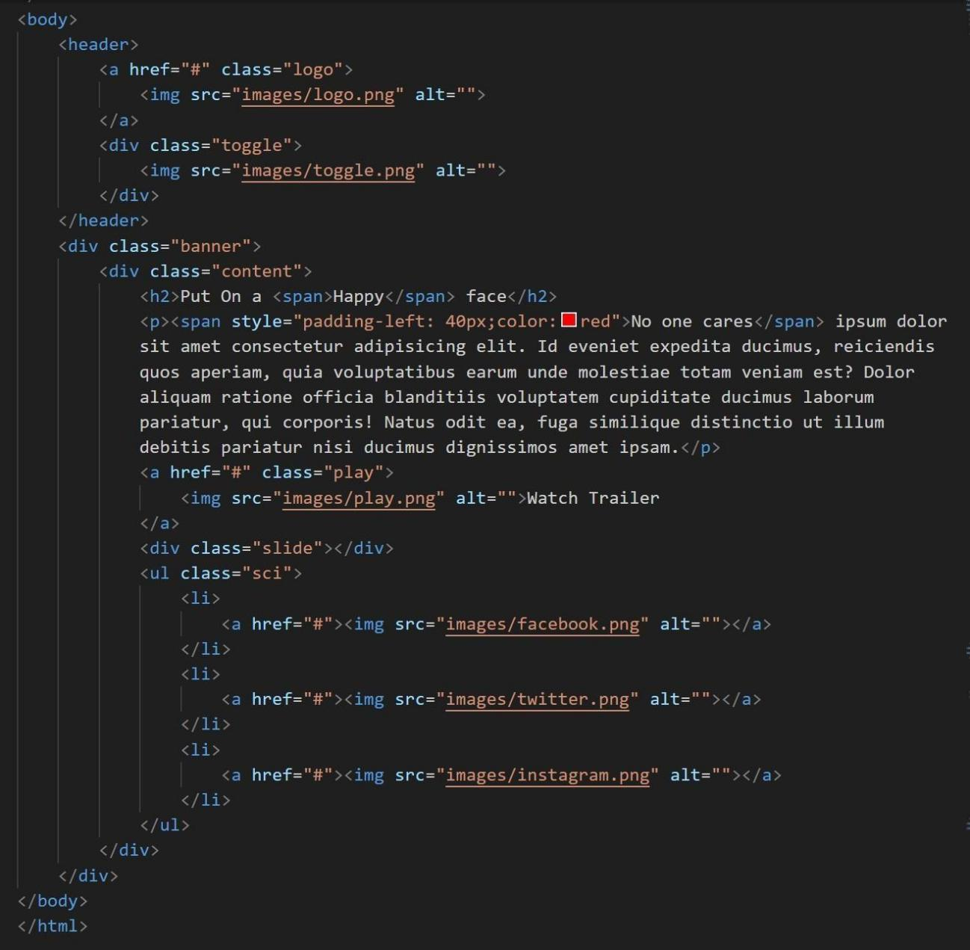



**Output :**